**Report on Photo Booth? (Using WEBRTC)**

Mere of the project “Photo Booth” is to build an application which is capable of supporting to click an image, crop it with intended dimensions and eventually save it on to a server, all at a place.

In a way towards construction of the project, jsfiddle is been used for integrating the whole functionalities into a single. HTML5 part is been used for placing html elements and deciding the page layout. CSS for styling so as to enrich the look and feel of application. Javascript, supporting code for application is been written in this space.

Initial screen looks as below

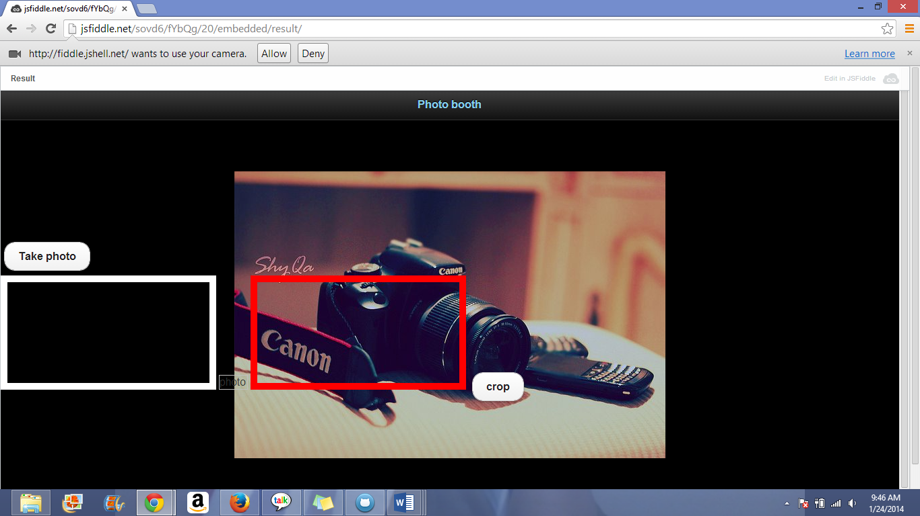

Here it questions for the allowance/denial for using camera that is fixed onto your device for clicking image. Click “Allow” so as to proceed.

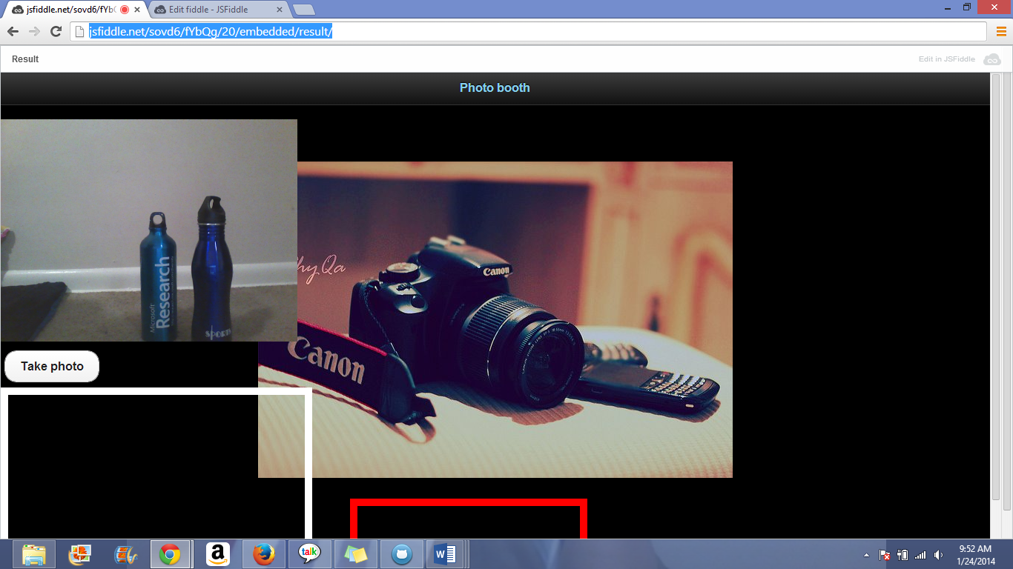

Streaming of video in the video element indicated that it can now be used for clicking our own images.

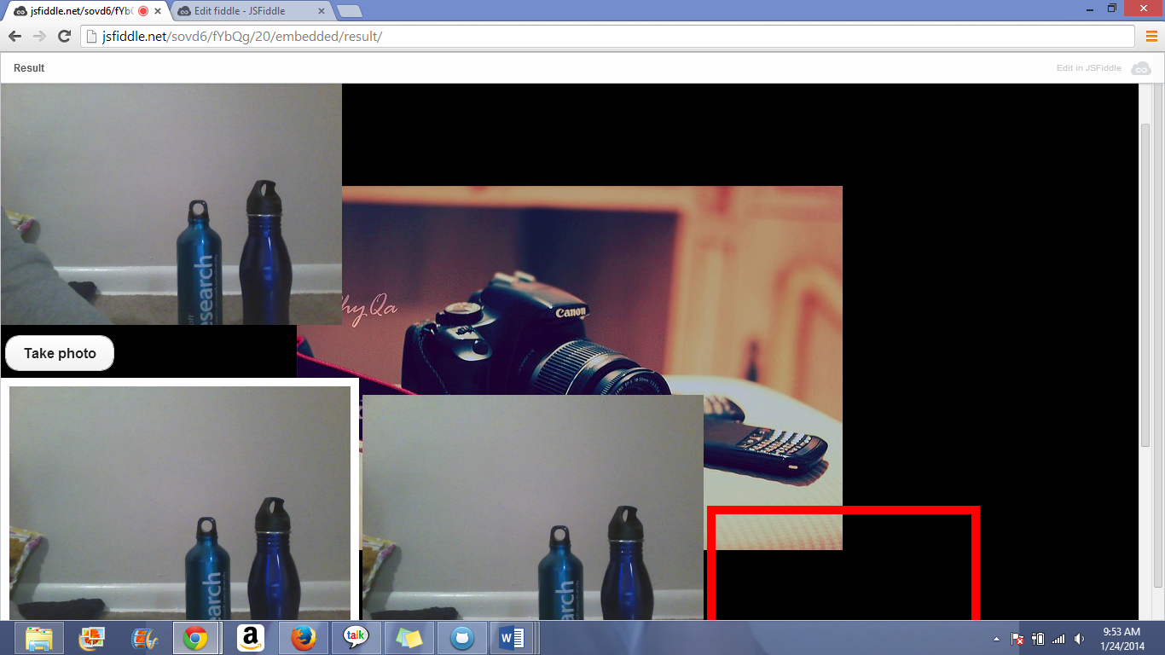

Click on “Take photo”, it then captures exact scene picture that is exists before it (lens).

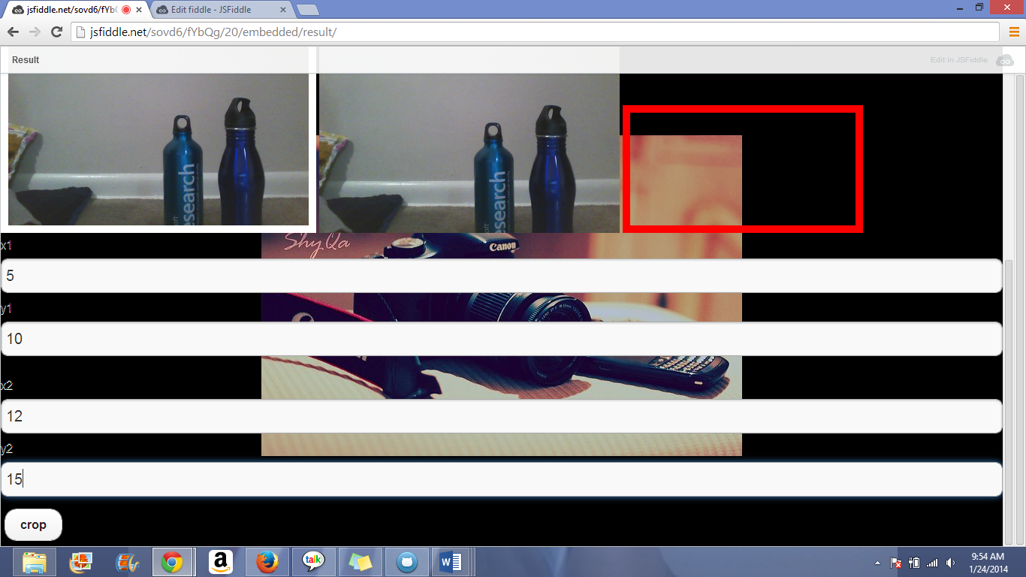

Next feature is associated to cropping of the picture. Enter the required entries x1,x2,y1,y2.

X1-the location of the start from left corner of the canvas (desired crop from the left corner of the image)

X2- measurement of the intended cut off from the right corner of the image

Y1- measurement of desired cut off from the top region of the image.

Y2-cut off measure intended from the bottom part of image.

Note: all the above values are taken in % formats.

In the test project 5% off left edge, 10% off top, 12% off right edge and 15% off the bottom is needed

This implies x1 as 5; x2 as 12; y1 as 10 and y2 as 15.

After entering these values click on crop button, it then successfully crops the region.

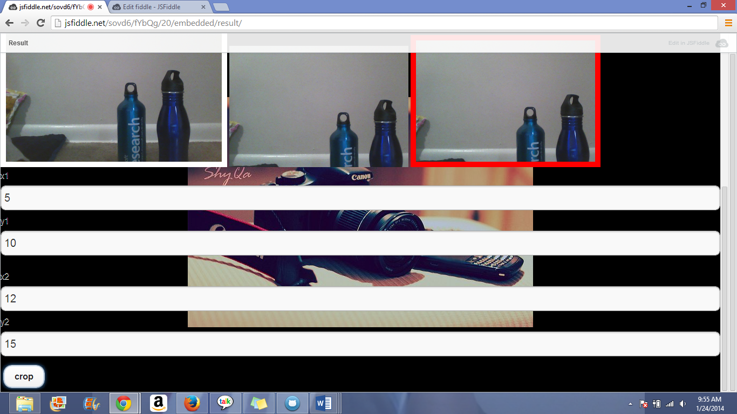

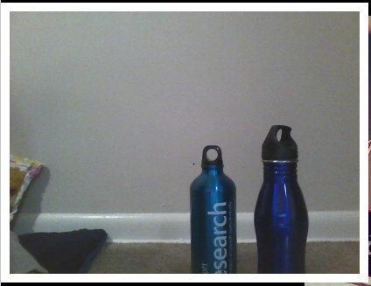 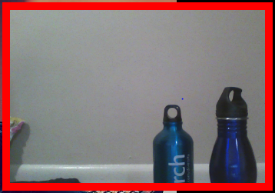

Above picture clearly distinguishes the image before cropping and after cropping.

Source link:

<http://jsfiddle.net/sovd6/fYbQg/20/embedded/result/>

Limitations:

* There may be difficulty that could be noticed with respect to the browser compatibility, for photo booth google chrome is preferable to use.
* As we keep varying browsers, image dimensions may also varied.
* Overlap of image space can be noticed this is due to the single image element usage. (ie photo).

References:

<http://www.webrtc.org/>

<https://developer.mozilla.org/en-US/docs/WebRTC>

<http://andrew.hedges.name/experiments/aspect_ratio/>

<http://www.html5canvastutorials.com/tutorials/html5-canvas-image-crop/>

<http://codepo8.github.io/interaction-cam/>